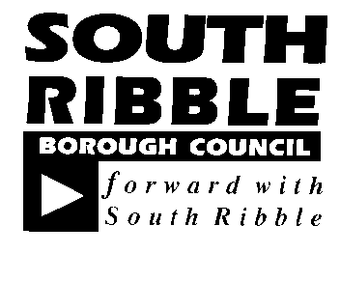  REPORT TO | ON
CABINET | Thursday, 29 October 2020
TITLE | PORTFOLIO | REPORT OF
Corporate Strategy Position Statement - Quarter 2, 2020/21 | Leader of the Council | Interim Chief Executive

Is this report a KEY DECISION (i.e. more than £100,000 or impacting on more than 2 Borough wards?)  Is this report on the Statutory Cabinet Forward Plan?  Is the request outside the policy and budgetary framework and therefore subject to confirmation at full Council?  Is this report confidential? | No  Yes  No  No

PURPOSE OF THE REPORT

- To provide Cabinet with a position statement for the newly approved Corporate Strategy for quarter two (July – September) 2020/21.

PORTFOLIO RECOMMENDATIONS

- The Scrutiny Budget and Performance Panel are asked to consider the report and make comments and recommendations to the Cabinet.

- Cabinet is asked to consider and comment on the report.

REASONS FOR THE DECISION

- The Council’s newly agreed performance framework (agreed 14th October 2020) sets out the process for reporting progress against the objectives of the Corporate Strategy. Robust monitoring ensures that the council continues to deliver its priorities and achieves the best outcomes for residents.

EXECUTIVE SUMMARY

- This report presents a position statement for the Corporate Strategy at the end of quarter two (July-September 2020). The strategy was approved by Council on the 30th of September and work is well underway to mobilise project delivery and performance monitoring activity. This report presents an update on the current position for the 14 projects and 24 performance measures.

- Project documentation has now been completed for the majority of the projects to define specific milestones, timescales and resource requirements. Of the 14 projects in the strategy: eight are already in progress, rated green and on track; six have yet to commence and are planned to commence later in the programme.
- Following the approval of the new performance measures, a baselining exercise is being completed to collect data ready for reporting performance information at quarter three. Of the indicators that can be reported, four are currently rated green and two are rated amber.

CORPORATE OUTCOMES

- The report relates to the following corporate priorities: (tick all those applicable):
An exemplary council | 
Thriving communities | 
A fair local economy that works for everyone | 
Good homes, green spaces, healthy places | 

BACKGROUND TO THE REPORT

- At Council on 30th September 2020, the Corporate Strategy was updated and refreshed to ensure that the Council can continue to meet the needs of the borough given recent changes, the impact of Covid-19 and future priorities.
- The four priorities identified in the strategy are:
- An exemplary council;
- Thriving communities;
- A fair local economy that works for everyone;
- Good homes, green spaces, healthy places.

- Activity and resources are now targeted towards 14 priority projects which are a combination of new and existing activity to be delivered over the next 12-18 months and measured using 24 revised performance indicators. This report provides the status of the projects and measures at the end of quarter two.

- A red, amber, green rating system is used to indicate status whereby:

RED | Off track
AMBER | Forecast delays or concerns, an early warning of issues
GREEN | On track and progressing as planning

Performance Indicators Direction
 | Amber arrows indicate the direction is negative and heading away from the target or is lower than its previous reporting period.
 | Green arrows indicate the direction is positive and improving or heading towards target.

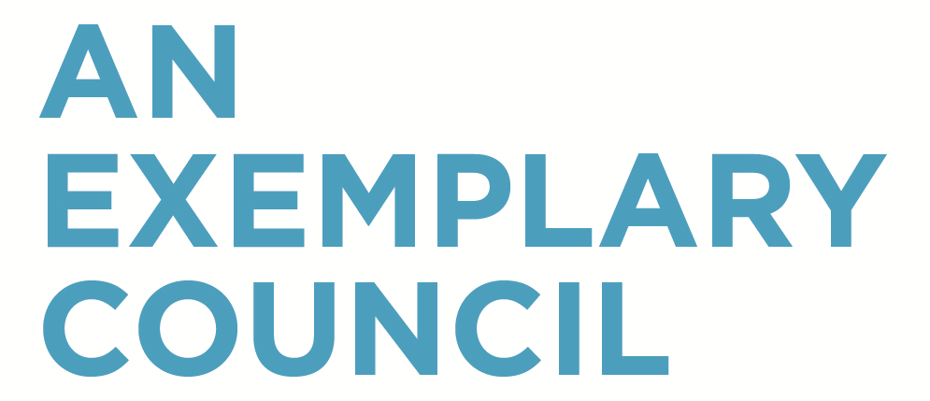

A COUNCIL THAT:
Delivers high performing services that represent value for money | Understand the community and work with partners to make things better | Is open and transparent in its activities

- Of the four projects within this priority, three are green and on track and one has not yet started.

Deliver the Annual Governance Statement Action Plan:  Including a review of governance policies, development of a consultation toolkit and key partnerships framework | GREEN
The implementation of the annual governance action plan has progressed well with a number of key actions completed to support the council’s commitment to openness and transparency:

- All policies that were to be reviewed within August have been completed and are known to be compliant.
- Governance and ethical awareness training on the Council’s Constitution and decision-making processes has been delivered, the Scheme of Delegation has been redrafted and the financial regulations are in the process of review.
- The Shared Service Joint Committee has considered and approved service reviews at its August meeting and the shared performance management framework was approved at Cabinet on 14th October 2020.
- An Organisational Development Strategy has been developed ahead of the initial timescale and has been approved by leadership team and its implementation is underway. This strategy aims to engage staff in key areas of development to support a positive culture of trust and accountability.

Transform the way the council operates:  Through the implementation of the first phase of shared services, development of the next phase and ongoing support for staff. | GREEN

Good progress has been made in delivering shared services to ensure that the council has a sustainable delivery model that is fit for the future. Key milestones include:
- Finalising the proposals for the phase one service reviews, designed to develop a single operating model for the new shared services.
- Preparing for the implementation of the service reviews.
- Preparing the business case for phase two of shared services.

Work has been completed on the restructure element of the phase one service reviews including informing staff, preparing job descriptions, formal consultation, ringfencing, preparation for the selection process, and job evaluation panels.

Proposals for the business case for phase two of shared services have been developed including an outline of the proposals, single operating models for customer and ICT as well as leadership proposals.
Deliver year one of the joint digital strategy:  To deliver better, more efficient services. | NOT YET STARTED
This quarter a position paper was put together which sets out the digital aims and aspirations of South Ribble Council and Chorley Council to inform the development of a joint digital strategy. The proposed joint digital strategy was considered by the Shared Services Joint Committee in September who recommended it to Council for approval. The joint digital strategy will be formally approved by Council in November

However in the meantime work is continuing on the implementation of the South Ribble digital strategy projects such as the refreshed Website, and mobile device roll out together with ICT support for phase 1 shared services and the Councils response to the Covid 19 pandemic such as the development of an online process for business grant applications and South Ribble together requests for support.

Work with partners to design and deliver better public services:  Through the South Ribble Partnership | GREEN
Over the past quarter the Partnership has been focused on continuing to develop the ‘One Front Door’ project which seeks to deliver better public services by providing a triage at first point of contact and better referral pathways to supporting organisations. The service is due to go live in quarter three with a partnership between South Ribble Borough Council and Citizens Advice Lancashire West who will be providing support on triaging incoming calls from residents in need of assistance.

Infrastructure development work continues with the voluntary and community sector and establishing a more defined network of groups working with Tempo and the Time Credits project.

This quarter South Ribble Partnerships’ Leadership and Executive Board agreed to begin developing proposals on how it can work closer and align workstreams with Chorley Public Service Reform Partnership to achieve greater impact and influence. Each partnership board will be considering a roadmap for alignment at their meetings in December 2020.

Key Performance Indicators
- Of the five performance measures reported under this outcome, one is due to be reported this quarter and rated green.

Key Performance Indicator | Target | Comparable Period | Quarter 2  2020/21 | Direction | Status
At least 40% of service requests will be received via self-service channels | 18% (2019/20)  29% (2020/21)  40% (2021/22) | 37%  (Q1:2020/21) | 32% |  | GREEN
Commentary | Performance is on track against the target. Quarterly variations mean that it is lower than the previous quarter due to a large online take up of the garden waste subscriptions in quarter one which increased the number of self-service transactions. Further to this the electoral canvassing has taken place during quarter two which is a largely telephone and currently paper-based with less opportunity to promote self-service.  The joint Digital Strategy will set out further actions to increase self-service as a priority. The launch of the refreshed corporate website will also present a more user-friendly experience to encourage more people to complete tasks online. The 40% target is considered achievable by the end of March 2022 as intended.

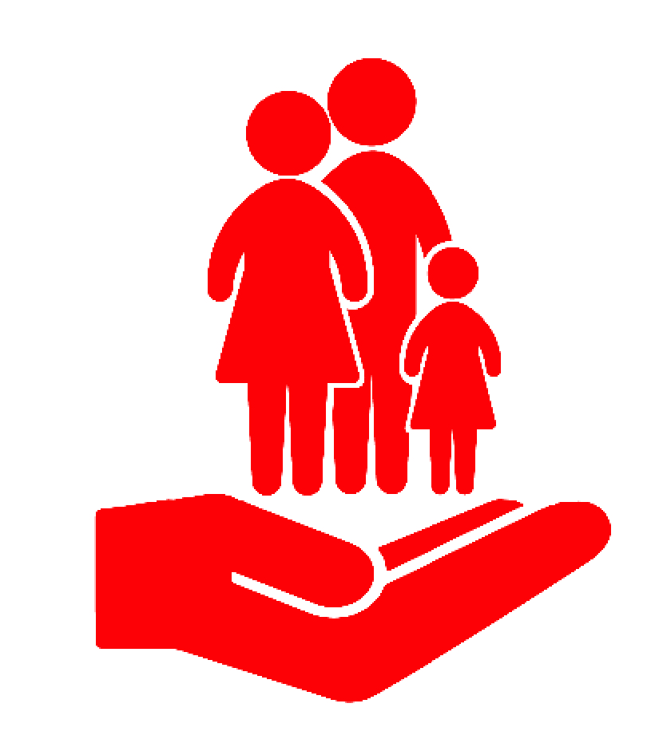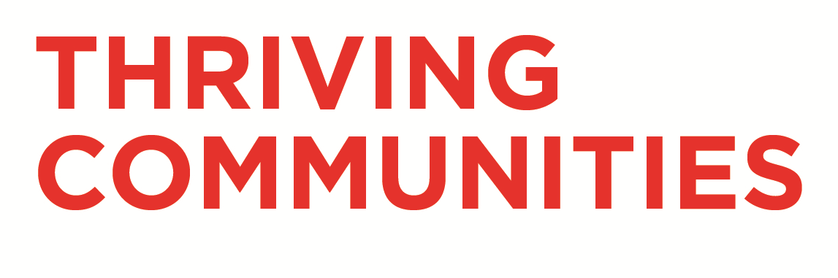

A PLACE WHERE:
Residents have positive mental health | People get involved and have a sense of belonging | Communities can access services and support when they need them

- Of the three projects within this priority, one is green and on track, two are in development and therefore not yet started.

Establish South Ribble Together Hubs:  Agreeing plans for neighbourhood areas and a borough food bank network | GREEN
The South Ribble Together Hub model has been developing over the last quarter, building on the approach taken in response to Covid-19 to ensure that communities can access services and support when they need them.

Recruitment to the Community Involvement team has been completed and the four officers are due to commence in post in quarter 3. Neighbourhood intelligence profiles will be scoped and developed over quarter 3, once all officers are in post, to help define and design how the hubs should operate.

The One Front Door approach will further enhance the support available through the hub network by ensuring a clear pathway to services and advice as part of a cohesive offer. Following the initial development work completed by the South Ribble Partnership, the One Front Door service will be formally launched by the Community Involvement Team in quarter three.

Deliver a mental health support programme for young people:  Building on the recommendations of young people who took part in the MH2K project. | NOT YET STARTED
The council is making it a priority to support mental health, particularly in young people. The previous work undertaken through MH2K has provided rich source of evidence and youth led recommendations that the council will now apply through the way that services are designed and delivered.

This project is at scoping stage to define a brief and develop the process for commissioning a provider with expertise in mental health to work with young people to develop and launch a support package whilst people are either waiting for formal mental health provision or are unable to access any provision. Options currently being explored include working with local providers to offer mental health coaching for young people as part of a sustainable peer support model.

The scoping should be complete by March 2021 and project to launch September 2021.

Establish a youth council:  By working with schools to promote democracy and design a model that works for young people. | NOT YET STARTED
This project will be to establish within schools over the academic year 2020-2021 an education package that is linked to the national curriculum which will enable schools to develop
- Debate clubs
- Mock council meetings

The delivery plan is currently being scoped and will be completed once the officer which has been recruited to support this project is in post after 23rd October 2020.

- Of the seven performance measures reported under this outcome, five are not due to be reported this quarter and the remaining two indicators require to be baselined, these are:
- The number of residents benefitting from opportunities created by the communities team
- Number of people who have successfully completed basic digital skills training

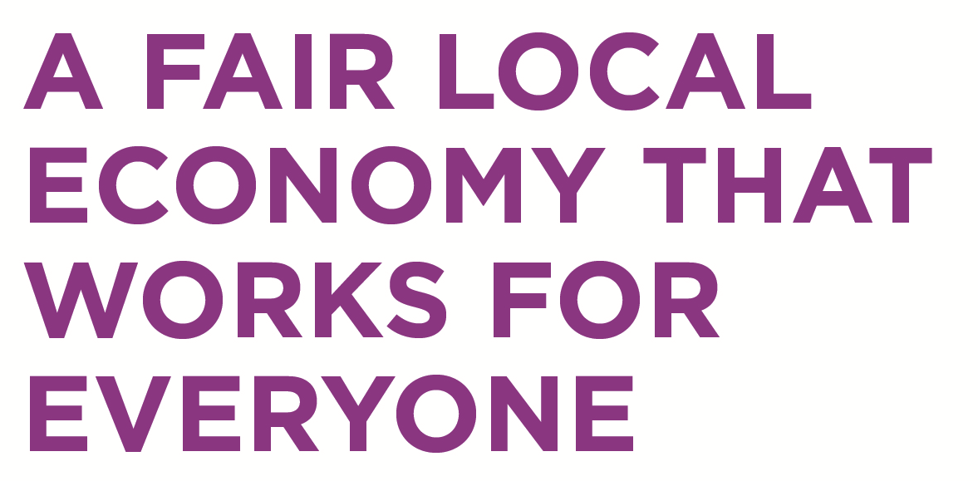

A COUNCIL THAT:
Increases access to training and jobs | Grows and supports sustainable businesses | Invests in improving the borough
- Of the three projects within this priority, one is green and on track, two are in the process of being scoped and developed to commence quarter three.

Implement the community wealth building action plan:  To retain wealth and grow the local economy. The project will focus on year one actions to start the movement in South Ribble, including a progressive procurement framework and social value policies | NOT YET STARTED
This project is subject to scoping and finalisation of the action plan to take forward the strategy. Over the last quarter it has been presented to the South Ribble Partnership, who will be having further workshops on social value procurement and social responsibility charter in November.

The action plan will be developed over the next quarter and be reported to Cabinet in November where further details on implementation will be agreed.

Establish a business support programme:  To meet the longer term needs of businesses as they recover from | NOT YET STARTED
Supporting businesses to be sustainable is a key challenge, particularly with the impact of Covid. The project is being scoped to understand what the needs of businesses are and how they can best be supported through grant provision supporting existing packages that have been provided by the government as part of covid-19.

Engagement with businesses is aimed to take place by the end of quarter three and a report to Council in March 2021.

Deliver year 1 of the Town Deal:  Including the bid to central government and preparatory works. | GREEN
The Town Deal proposal sets out a range of activities that support investment within the borough impacting on skills and businesses. Progress throughout quarter two has been positive. Consultants Steer and WYG were appointed to complete the Ministry of Housing, Communities and Local Government (MHCLG) readiness questionnaire and supported the Council with the development of the Town Investment Plan (TIP).

A draft TIP has now been completed and will be submitted to the Leyland Town Board to refine and finalise in October 2020.

The Town Investment Plan will include:
- Create a new ‘heart’ of Leyland with a distinct Town Centre offer for residents and visitors with new and diverse commercial and residential space.
- Deliver skills infrastructure, enterprise infrastructure and urban regeneration that will provide new public spaces that support business start-up, skills and accessibility to training space and equipment and improve the local arts and culture offer.
- Create improved sustainable connectivity to reduce carbon emissions locally.

Following the approval of the TIP, the next stage of the Town deal project will be to start on the design work and complete a comprehensive business plan.

Key Performance Indicators
- Of the four performance measures reported under this priority, two measures are due to be reported this quarter and both are rated green.

Key Performance Indicator | Baseline /  Target | Quarter 1 2020/21 | Quarter 2  2020/21 | Direction | Status
Overall employment rate greater than north west average | 74.9% | 87.4 | 84.8 |  | GREEN
Commentary | South Ribble’s overall employment rate is above the current mean for all north west local authorities. Performance is lower than quarter one however the borough continues to perform well on employment with the 3rd highest employment rate across the region.

Key Performance Indicator | Baseline /  Target | Quarter 1  2020/21 | Quarter 2  2020/21 | Direction | Status
% 16 -17 year olds not in education or training (NEET) | 3.5% | 3% | - |  | GREEN
Commentary | The most recently available data for this measure relates to quarter one and indicates positive performance with the percentage of 16-17 year olds not in education or training (NEET) to be lower than the target, 3% compared to a 3.5% target based on previous performance. The trend is positive with performance going in the right direction.

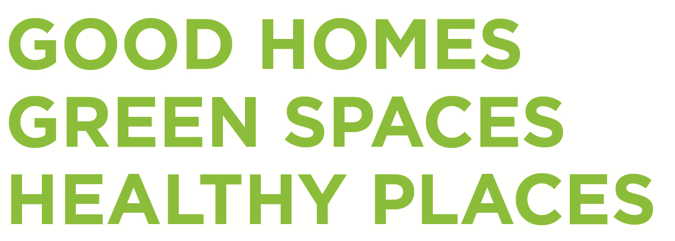

A BOROUGH WITH:
A choice of decent, affordable housing | Commitment to protecting the local environment | A choice of quality recreational activities
- Of the four projects within this priority, three are green and on-track, one has not yet started and is currently being scoped to commence later in the year.

Bring Worden Hall back into use:  By delivering phase 1 including planning permission, procurement and contract award | GREEN
An update has been provided to Scrutiny Committee on 22nd October which sets out the progress to date and forward plan in delivering phase one and ensuring that the project delivers quality recreational spaces. Within the quarter a significant amount of pre application based preparatory works have taken place including site and conditions surveys, environmental and ecology surveys and initial architectural, structural and landscape designs.

The development of the planning application is running to programme, with Planning/Listed building consent due to be submitted to Planning in December with the application going to Planning committee in early 2021.

Deliver a project to support the green agenda:  To support the council’s commitment to carbon neutral | NOT YET STARTED
The council has a number of strategies and action plans that articulate its commitment to protecting the environment with a range of initiatives underway.

The council is actively working on an extensive programme of activity to support the green agenda. This project will focus specifically on a number of tangible actions and initiatives to be delivered over the next 12 months, taken from the wider programme

Deliver a leisure improvement project:  Refurbishing existing sites and enhancing facilities | GREEN
In October 2020, the cabinet considered a report to adopt the new South Ribble Leisure Facilities Strategy. The report outlined the proposals for investing in the current leisure centre stock in line with the Leisure strategy options.

The Project will deliver the activities identified in the investment plan for the existing leisure centres and will deliver the programmed work identified For a Football Hub at Bamber Bridge leisure Centre. This Hub will also include a Cycling Hub as part of the Councils Bike-ability scheme.

The first of the activities have already been planned and prepared within quarter two and is due to commence in October with resurfacing of the sports hall floor at Penwortham Leisure Centre.

Commence building of affordable homes within the borough:  Including the McKenzie Arms site and work to bring forward am Extra Care scheme | GREEN
Good progress has been made by the council in commencing build of quality and affordable home. Several sites and development projects have been taken forward.

- McKenzie Arms - Full planning permission was granted at the Council's Planning Committee on 27th August for the development of 15 new affordable rented homes and approval sought at Cabinet to take the project forward to the next stage. Next steps will include to undertake site preparatory work and to explore potential affordable housing grant funding now that a new funding programme has been announced.

- Extra Care - Following a review of potential sites, a report was considered at Cabinet on 16th September to recommend a preferred site to deliver the Council's first purpose built extra care scheme. Approval has been sought to take the preferred site forward in procuring a consultant team to undertake a feasibility study and prepare a business case for the scheme.

Key Performance Indicators
- Of the eight performance measures reported under this outcome, three performance measures are due to be reported this quarter with one rated green and two rated amber:

Key Performance Indicator | Baseline /Target | Comparable Period | Quarter 2  2020/21 | Direction | Status
Number of affordable homes delivered (bi-annual) | 80 | 81  (Q4:2020/21) | 12 |  | AMBER
Commentary | Lockdown and safety restrictions imposed in March 2020 to tackle Covid-19 resulted in a number of construction sites closing and paused until it was safe to reopen. In addition, covid measures have impacted the wider housing market and the sale of new homes Countrywide. This may impact the measure over the reporting period but is outside the council’s control.  However, the council’s own building programme for the McKenzie Arms and Extra Care scheme will positively contribute to raising the numbers of affordable homes however it may not reach the full target within the expected timeframe.

Key Performance Indicator | Baseline /Target | Comparable Period | Quarter 2 2020/21 | Direction | Status
27,500 Trees will be planted in the borough this year | 27,000 | 459  (Q1:2020/21) | 3,059  (running total) |  | GREEN
Commentary | Within quarter two a further 2,600 have been planted at Shruggs Wood and confidence in meeting this year’s target is positive as a further 16,000 trees have been ordered.

Key Performance Indicator | Baseline /  Target | Comparable Period | Quarter 2  2020/21 | Direction | Status
The number of people who are prevented from becoming homeless is increased | 341  (2018/19) | 69  (Q1:2020/21) | 90 |  | AMBER
Commentary | National measures to protect people from homelessness are still in place which has an impact on those who would be categorised as prevented under normal conditions. Notice periods are still under the 6 month suspension and so people who may have presented under normal circumstances have not come forward.  Where someone does present as homeless or at risk, the council continues to fulfil its duty and works with agencies to support and prevent individuals and households from becoming homeless.

CONSULTATION CARRIED OUT AND OUTCOME OF CONSULTATION

- N/A
ALTERNATIVE OPTIONS CONSIDERED AND REJECTED

- N/A
AIR QUALITY IMPLICATIONS

- N/A
RISK MANAGEMENT

- Risk registers are being completed for each project which will inform the wider risk assessment on an ongoing basis for the corporate strategy.

EQUALITY AND DIVERSITY IMPACT

- Equality and Diversity is embedded within the corporate strategy and how the council acts. An equality impact assessment was undertaken as part of the corporate plan refresh and each individual project will have its own equality impact assessment which are being revised and reassessed during quarter three.

COMMENTS OF THE STATUTORY FINANCE OFFICER

- Projects underway have been allocated revenue and capital budgets. Any new projects that require additional funding will be brought to the necessary committees for budget approval.

COMMENTS OF THE MONITORING OFFICER

- There are no direct legal implications arising from this report. The report is for information purposes. Obviously, it is important that members and the general public should know how we are performing in respect of our priority projects and against key performance indicators.

BACKGROUND DOCUMENTS

- Corporate Plan, approved September 30th, 2020

APPENDICES

- Appendix 1 for Quarter 2 July - Sep) Performance Monitoring Report 2020-21

Gary Hall
Interim Chief Executive

Report Author: | Telephone: | Date:
Howard Anthony, Michael Johnson (South Ribble Partnership Manager, Graduate Performance & Projects Officer) | 01772 625546 | 19/10/2020

